________________________________________________________

Northern Work Area - Lowtown
Lowtown, Chainage 0m to 400m – Pathway construction from sub-base to dust fully completed. See fig 1 below. At CH400 the new path is joined to existing bound access road. This bound surface continues to CH2200 at which point the 250m stretch of unbound surface is also complete and was receiving its final dressing last Monday when Fig 2 & 3 were taken. This is CH2200 to CH2450.
Bound surfaces are required from CH2450 to CH3250. The unbound blueway surface was completed in 2020 from CH3250 (Ballyteige) to CH7300 (Feighcullen). There is an existing bound surface, to be renewed, from CH7300 to CH8550 (Glenaree).
Site set up at Glenaree, including signage, fencing and closing of the trackway has commenced as of the 14th April. Excavation will commence at CH8550 imminently and continue on to Rathangan for early Q4 2021.
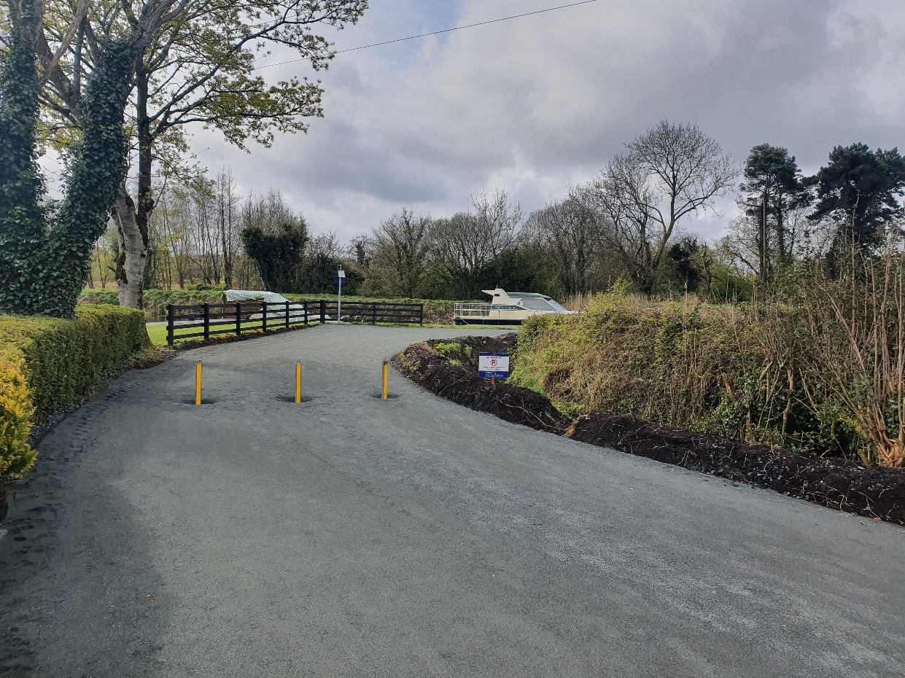
Fig1 – Taken at CH0 Lowtown looking South. This is the start of the Blueway.
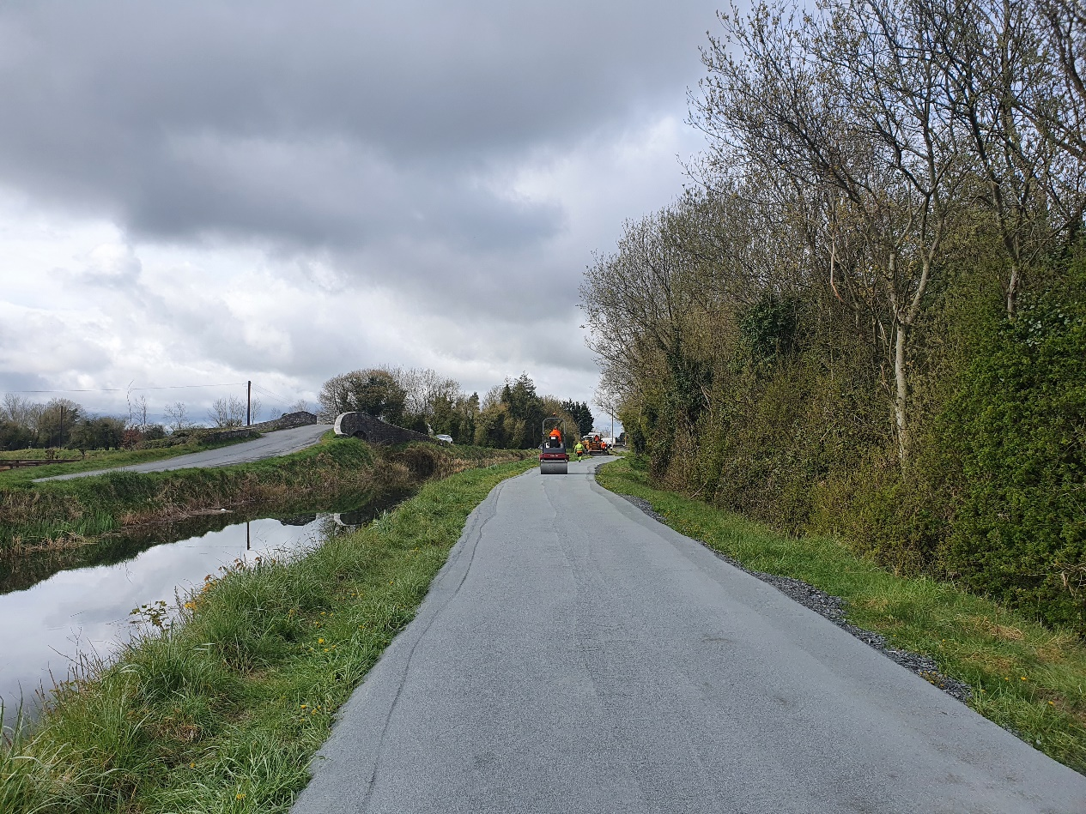
Fig 2 – CH2200m, Looking North. Huband Bridge and the Milltown feeder on the left of the photo. Blueway surface complete.
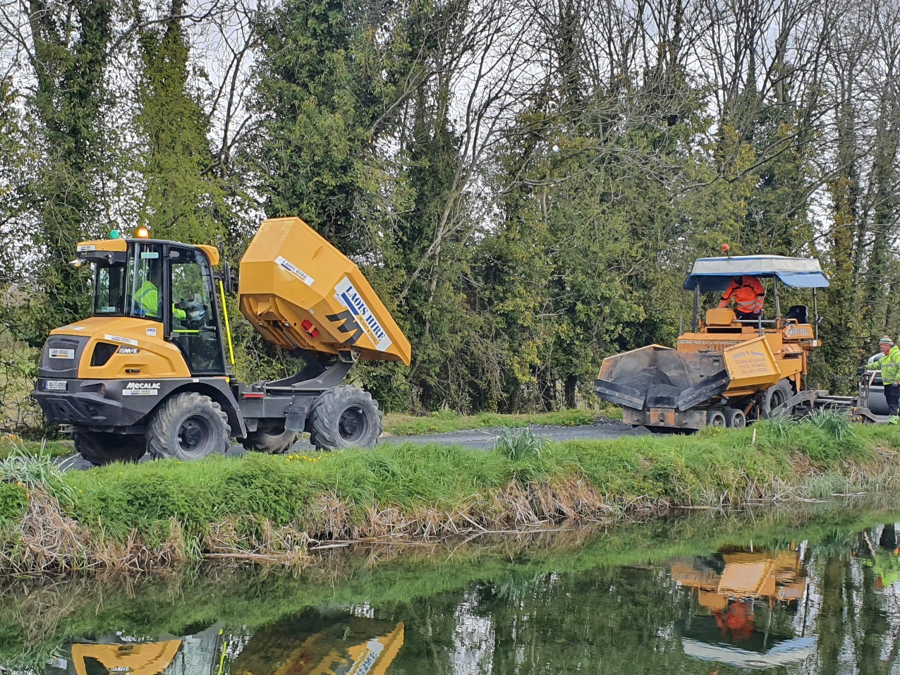
Fig 3 – Lock 19(Old) CH 2450m, Looking west across the canal at the final application of surface.
Southern Work Area – Ballymanus to Vicarstown
Completion of the construction of the section of Blueway from CH39900 at Ballyroe through to Ballymanus bridge at CH37050 is complete and this bank as re-opened to the public.
Progression of works between Ballymanus Bridge and Vicarstown CH35000 commenced 30th March 2021. Excavation, including the archaeological inspections around Camac aqueduct has been undertaken from CH37050 Ballymanus Bridge to approx. CH35600. Sub-base stone has been laid from Ballymanus to Camac Aqueduct CH36400.
Works are aiming to reach Vicarstown by end May 2021.

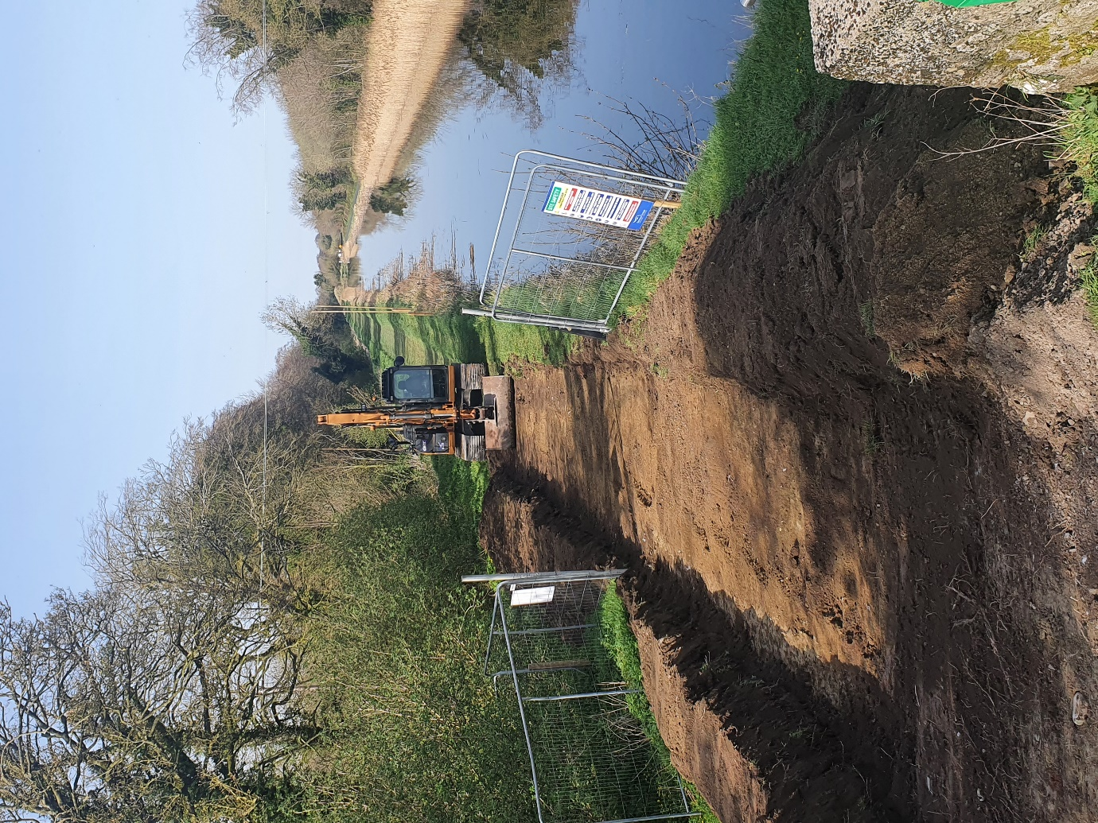
Fig 4 - CH37050 at Ballymanus, looking north. Excavation commenced.

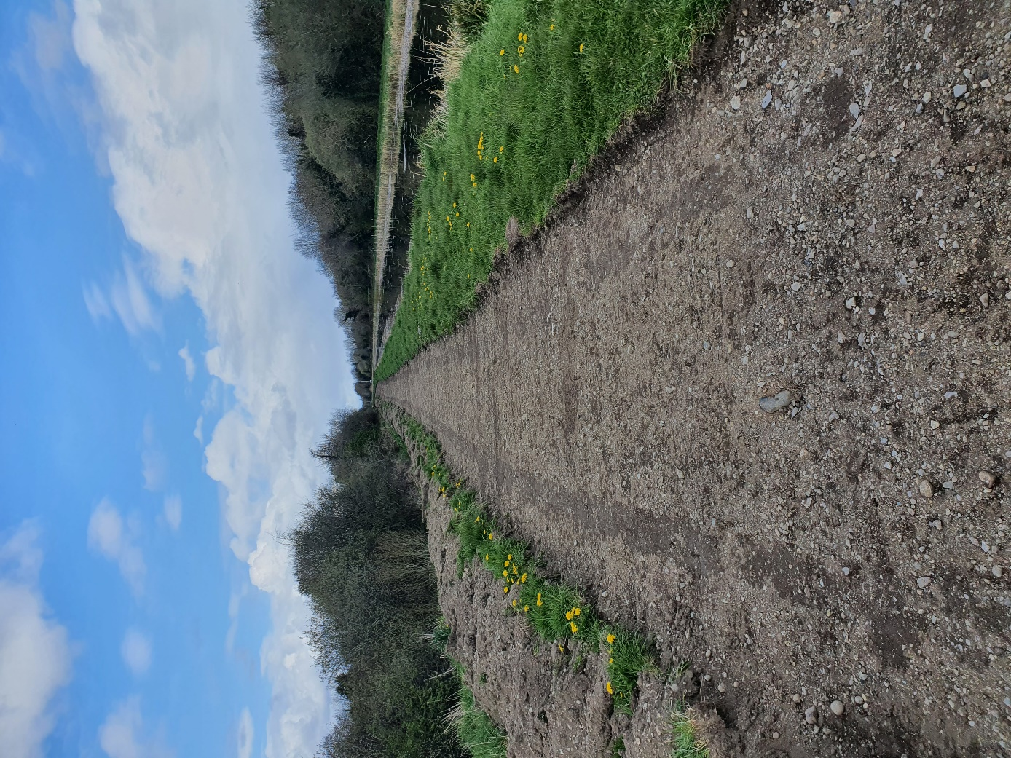
Fig 5 – CH36000 looking north. – excavation complete, awaiting stone.
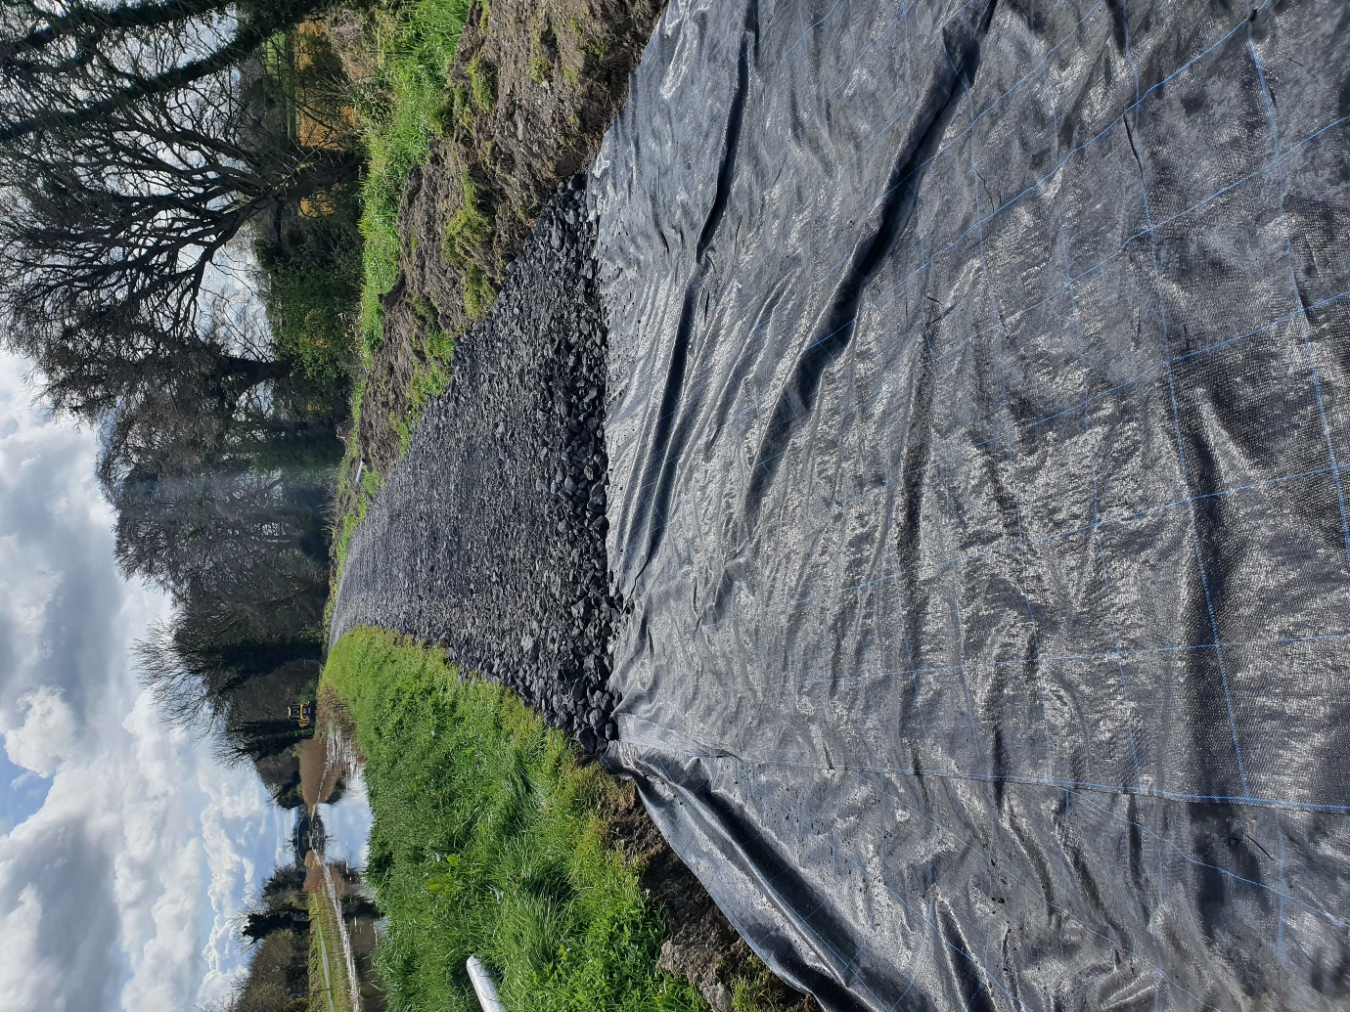
Fig 6 – CH36450 looking south to Ballymanus – stone subbase installation

